1. Install Visual Studio  
   **Use below link to connect database to .Net Core (not for .Net Framework)**  
     
   scaffold-dbcontext -provider Microsoft.EntityFrameworkCore.sqlServer -connection "Data Source = (localdb)\.;Initial Catalog=Employee CRUD" -OutputDir Models

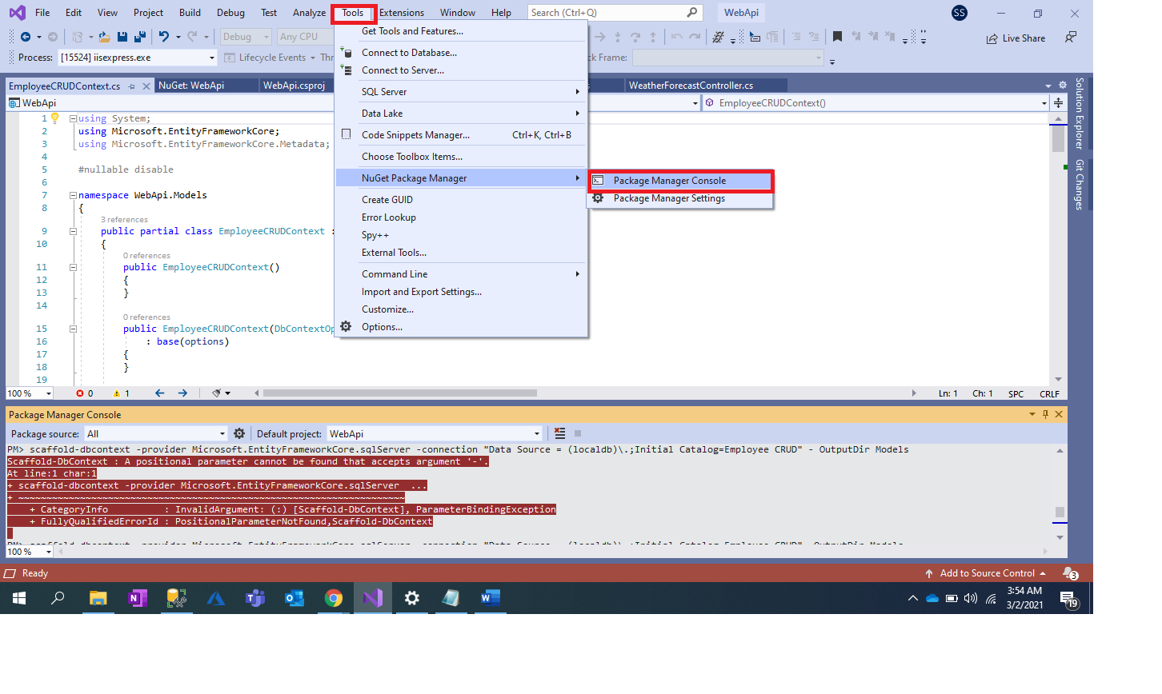 Install node.js (http://nodejs.org)

1. Install Visual Studio Code
2. Write command in node.js command promant
   * 1. Checking version : node -v
     2. Checking version : npm -v
     3. TYPESCRIPT: npm install -g typescript (www. Typescriptlang.org)
     4. ANGULAR CLI(COMMAND LINE INTERFACE): npm install -g @angular/cli
     5. Checking ANGULAR version : ng v
     6. Project add in folder: d: (enter)
     7. D:\> cd Sush
     8. D>Sush:\> cd STUDY
     9. D>Sush> STUDY:\> cd ANGULAR
     10. D>Sush> STUDY> ANGULAR:\> ng new MyAngularProjevt (this is our project name)
     11. D:\Sush\STUDY\ANGULAR> cd D:\Sush\STUDY\ANGULAR\MyAngularProject
     12. After loading all files🡪

D:\Sush\STUDY\ANGULAR> cd D:\Sush\STUDY\ANGULAR\> cd MyAngularProject

D:\Sush\STUDY\ANGULAR> cd D:\Sush\STUDY\ANGULAR\MyAngularProject/> ng serve

Or ng serve -o

* + 1. Localhost:4200 (type in google)

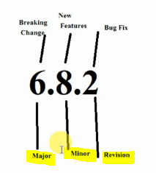

**^** 🡪 carrot (for upper level) for minor and revision

**~** 🡪 tillt (for upper level) revision for only revision

* Sequencing of folder 🡪 [Angular 8 Full Tutorial in Hindi](https://www.youtube.com/playlist?list=PL_qizAfcpJ-MhinmGp3nIUnPp_3rNW-Wc) video no.3, 21 min to 21:30

1. Create component: **ng generate component employee** or **ng g c employee**

@NgModule({

  declarations: [Component, Directives, Pipe],

  imports: [Module],

  providers: [ service],

  bootstrap: [AppComponent]

})

1. Create Module: **ng generate module company** or **ng g m company**
2. Create component in module : Ng g c **company/employeelogin**
3. Create Service: **ng generate service myservicexyz** or ng g service
4. KILL THE already use localhost **^c** (control C)
5. ADD below thing in **app.module.ts**(here example is Departmentcomponant and departmentservice)

import { DepartmentComponent } from './department/department.component';

import {DepartmentService} from  './department.service';

import {HttpClient} from '@angular/common/http';

import {FormsModule,ReactiveFormsModule} from '@angular/forms';

@NgModule({

  declarations: [

    AppComponent,

    DepartmentComponent

  ],

  imports: [

    BrowserModule,

    AppRoutingModule,

    HttpClient,

    FormsModule,

    ReactiveFormsModule

  ],

  providers: [

    DepartmentService

  ],

  bootstrap: [AppComponent]

})

export class AppModule { }

1. ADD below thing in **department.service.ts**(here example is Departmentcomponant and departmentservice)

import {HttpClient} from '@angular/common/http';

import {Observable} from 'rxjs';

@Injectable({

  providedIn: 'root'

})

export class DepartmentService {

  readonly APIUrl="http://localhost:51229/"

  constructor(private http:HttpClient) { }

  getDepList():Observable<any[]>{

return this.http.get<any>(this.APIUrl+'department')

  }

}

**Routing**

ADD below thing in **app-routing.module.ts**

(here example is Departmentcomponant and departmentservice)

import {DepartmentComponent} from './department/department.component';

const routes: Routes = [

  {path:'department', component:DepartmentComponent}

];

ADD below thing in **app.component.html**

<h1>Hello Word</h1>

<router-outlet></router-outlet>

Result: 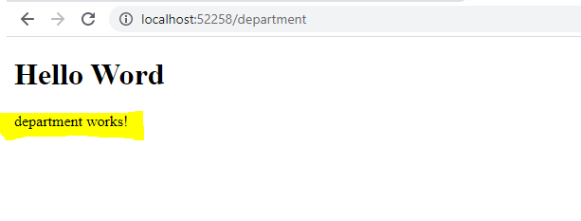

**Bootstrap**

ADD below thing in **index.html**(use url for bootstrap links: https://getbootstrap.com/docs/4.0/getting-started/introduction/)  
 **Head section**<link rel="stylesheet" href="https://maxcdn.bootstrapcdn.com/bootstrap/4.0.0/css/bootstrap.min.css" integrity="sha384-Gn5384xqQ1aoWXA+058RXPxPg6fy4IWvTNh0E263XmFcJlSAwiGgFAW/dAiS6JXm" crossorigin="anonymous">

**and   
Before closing body section**<script src="https://code.jquery.com/jquery-3.2.1.slim.min.js" integrity="sha384-KJ3o2DKtIkvYIK3UENzmM7KCkRr/rE9/Qpg6aAZGJwFDMVNA/GpGFF93hXpG5KkN" crossorigin="anonymous"></script>

<script src="https://cdnjs.cloudflare.com/ajax/libs/popper.js/1.12.9/umd/popper.min.js" integrity="sha384-ApNbgh9B+Y1QKtv3Rn7W3mgPxhU9K/ScQsAP7hUibX39j7fakFPskvXusvfa0b4Q" crossorigin="anonymous"></script>

<script src="https://maxcdn.bootstrapcdn.com/bootstrap/4.0.0/js/bootstrap.min.js" integrity="sha384-JZR6Spejh4U02d8jOt6vLEHfe/JQGiRRSQQxSfFWpi1MquVdAyjUar5+76PVCmYl" crossorigin="anonymous"></script>

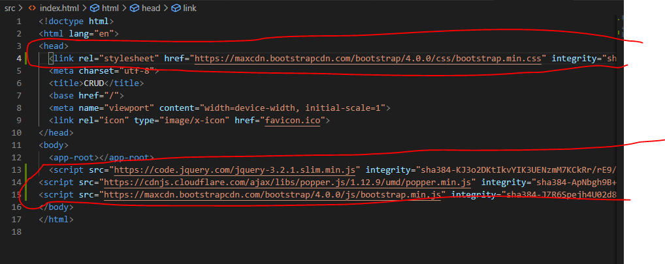

**Navigation Menu**

VIDEO 6:

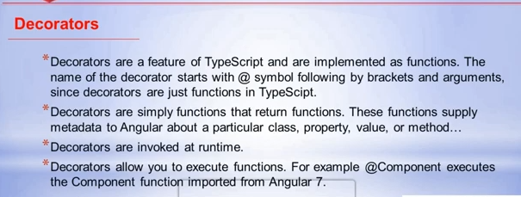

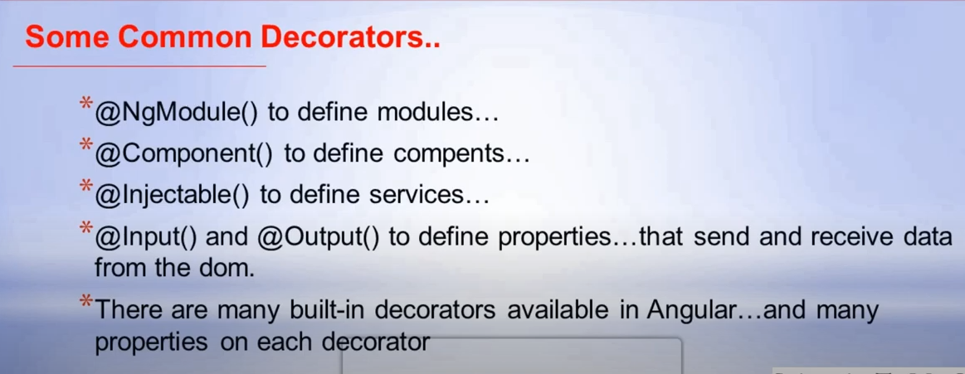

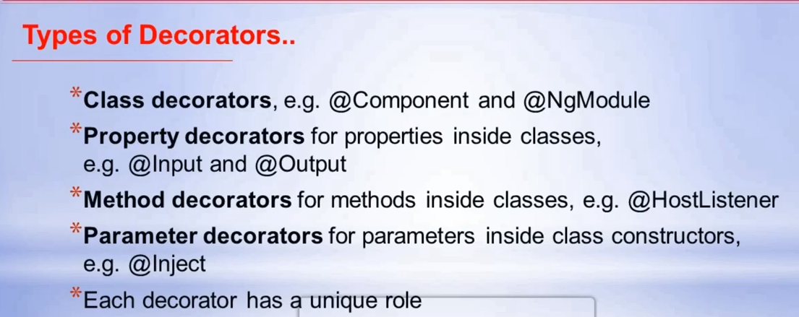

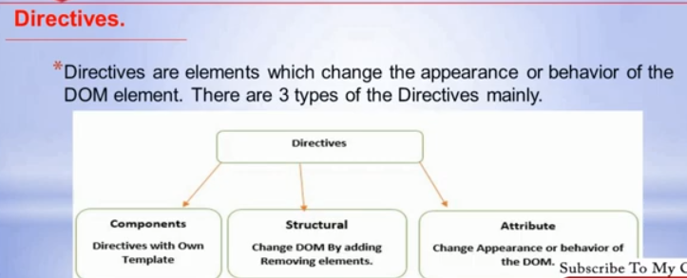

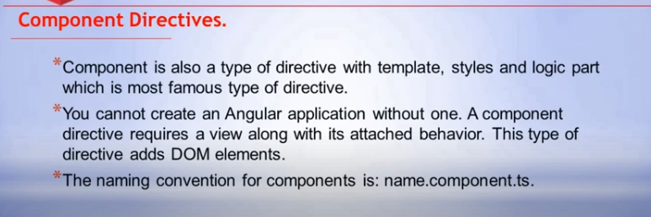

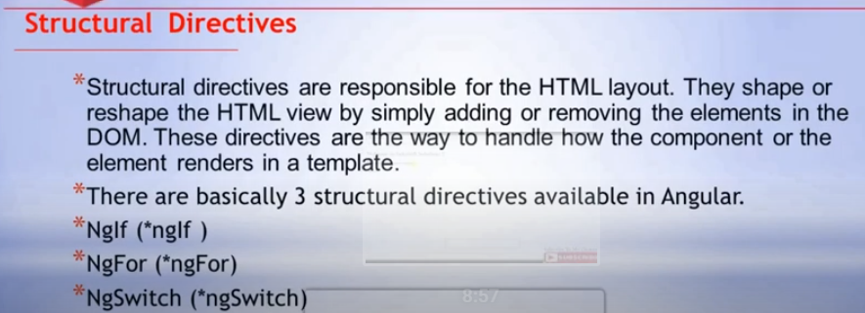

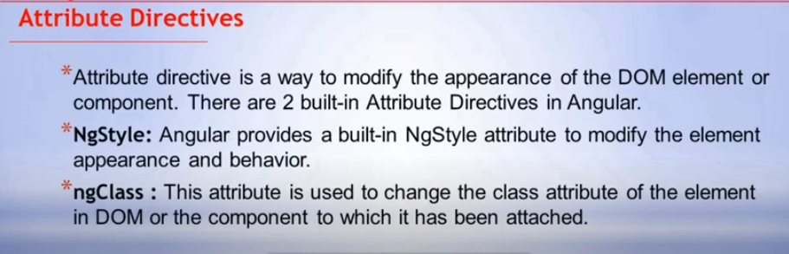

**Video 9:**

